# Azure Compute – Web Apps

## Objectives

In this hands-on lab, you will learn how to:

* Provision a Web App
* Deploy a web application the Web App in Azure

## **Prerequisites**

The following are required to complete this hands-on lab:

* An active Microsoft Azure subscription
* Visual Studio 2017 Community or greater (Professional or Enterprise)

## Exercises

This hands-on lab includes the following exercises:

* Exercise 1: Provision a Web App
* Exercise 2: Create and deploy a sample application

Estimated time to complete this lab: 10 - 30 minutes

# Exercise 1: Provision a Web App

In this exercise, you will use the Azure portal to create a web app.

1. Go to the Azure Portal <https://portal.azure.com> and sign into your Azure account
2. Click the + New (or use keyboard shortcut N) to open the **New blade**, the type **web app** into the search box and hit **enter**

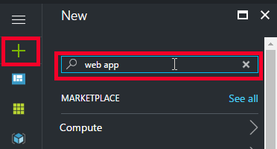

This will open the search results blade.

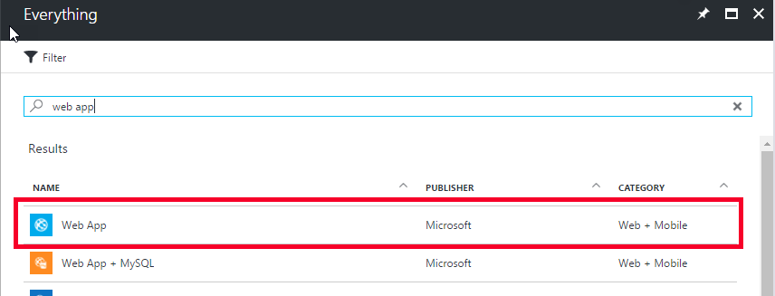

1. Select **Web App**

This will show the information about the web app product.

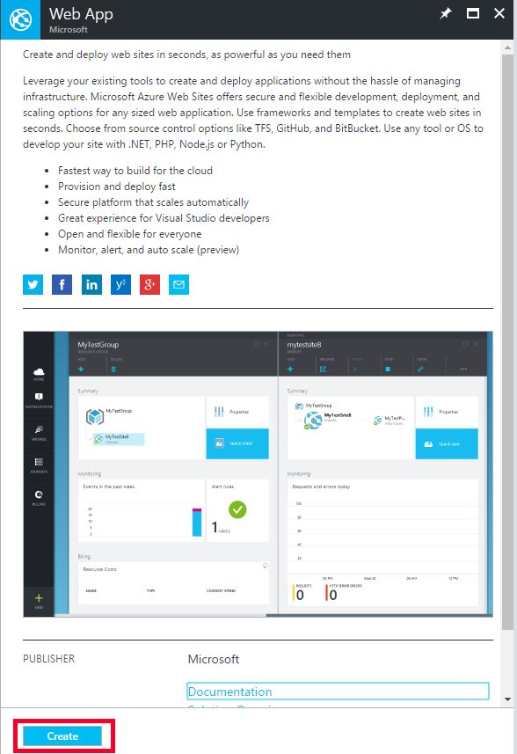

1. Click the **Create** button

This will open the Create Web App blade.

1. Fill in the following information for the web app:

* **App name:** GABWebApp<your first name>
* **Subscription:** choose your subscription
* **Resource Group:** Create new
  + **Enter name of:** GABWebAppLab

1. Click on **App Service plan/Location** and select **Create New**
2. Fill in the App Service Plan information:

* **App Service plan:** GABWebApp
* **Location:** East US

1. Click on the **Pricing tier** to see the different pricing cards and select **S1 Standard**

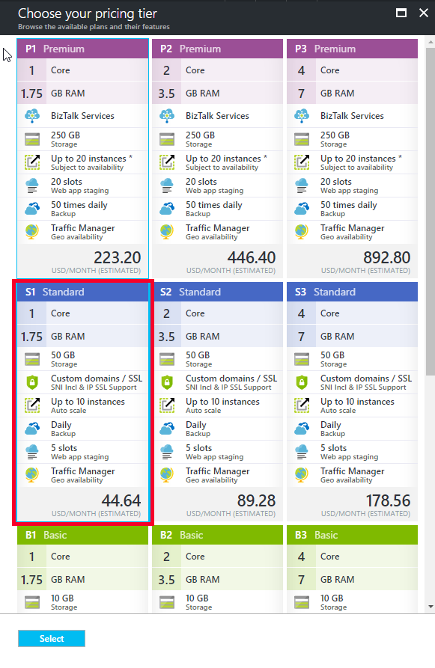

1. Click **Select**
2. Click **OK**

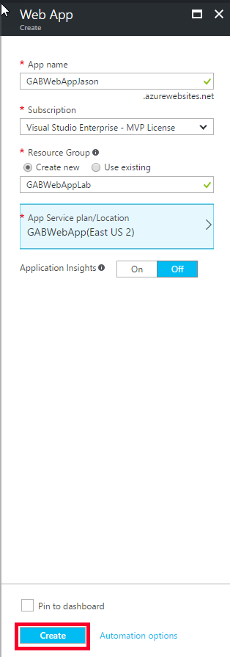

1. Click **Create** to start the provisioning of the new Web App

The provisioning should take 1-3 minutes.

1. In the upper right corner, click on the **notification bell icon**

This will show the list of notifications.

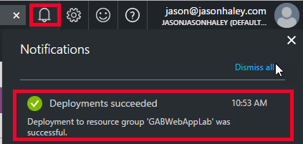

1. Once you see the Deployments successful notification, click on it.

This will take you to the Web App Overview blade.

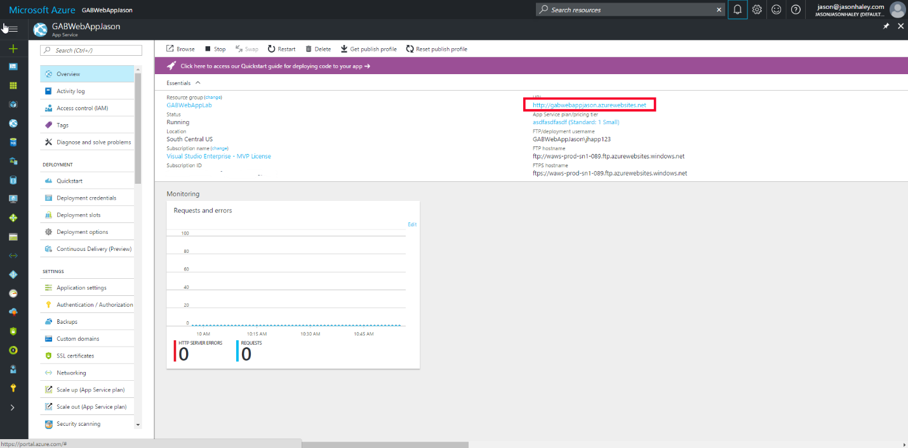

1. In the upper right corner of the Essentials panel, click on the URL for your web app

This will show you the starter page letting you know the web app is up and running.

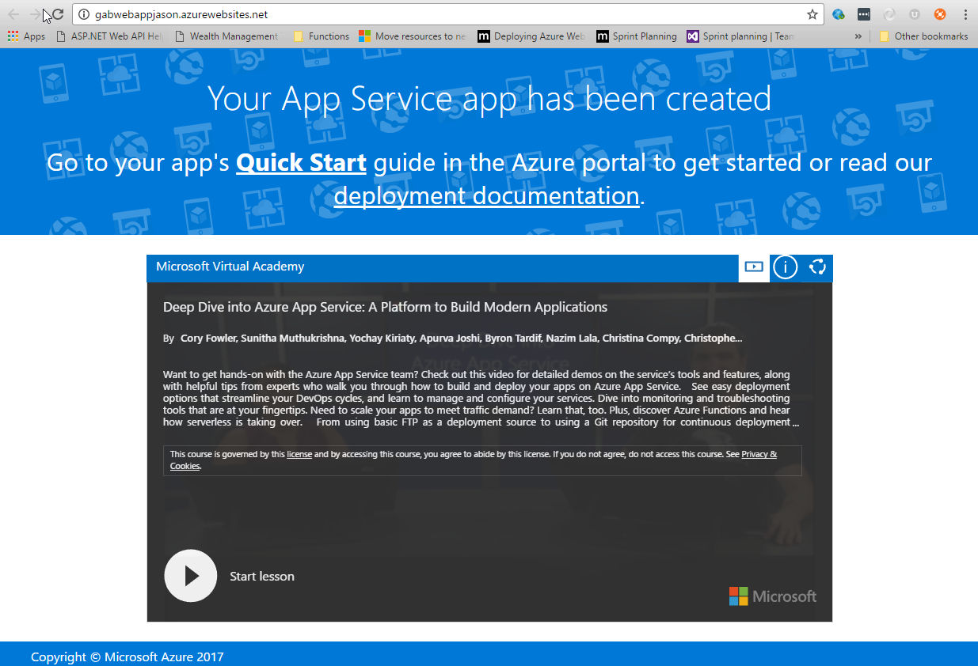

The next step is to deploy your own code to the web app.

# Exercise 2: Create and deploy a sample application

In this exercise, you will create a sample web application to deploy to the web app you just created in Exercise 1.

***NOTE: If you completed the Azure Compute Virtual Machines Lab you can use the same Web Application you created in Exercise 5.***

1. Open Visual Studio 2017 Community edition (or greater)
2. File -> New Project

This will show the New Project dialog

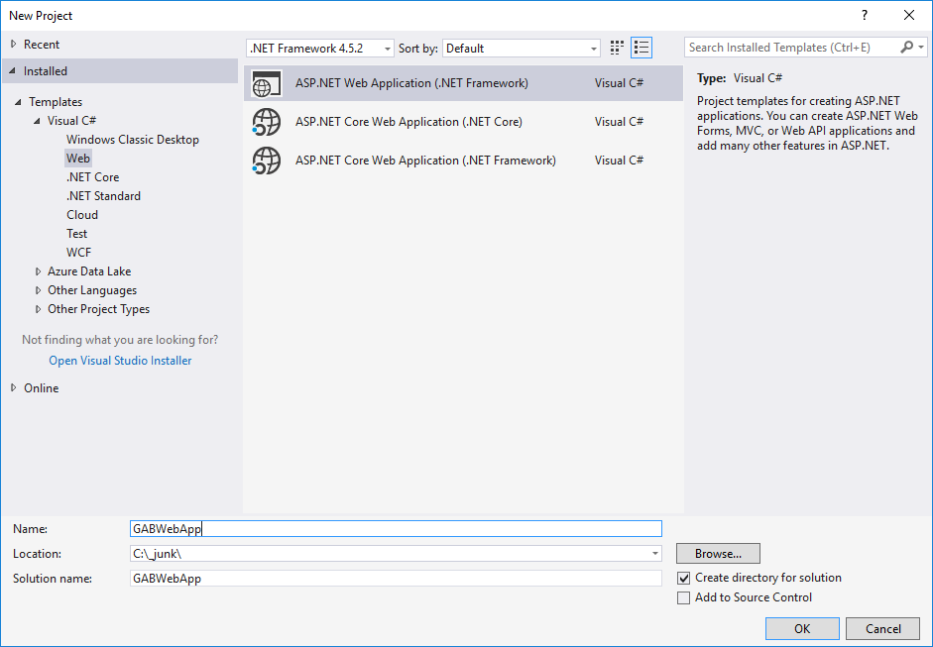

1. Select **Web** from the templates and select **ASP.NET Web Application (.NET Framework)**
2. Give the project a name of **GABWebApp** and select a folder to save the project to
3. Click **OK**

This will show the New ASP.NET Application dialog

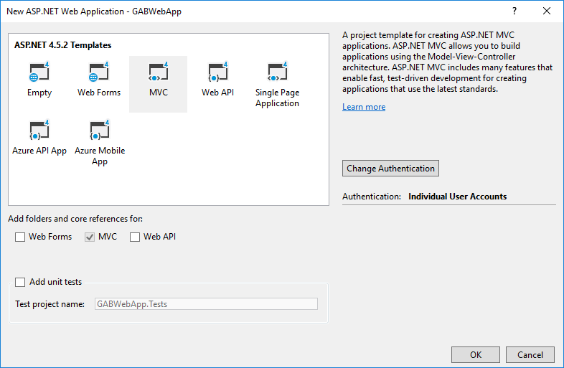

1. Select **MVC** from the template listing and click the **Change Authentication** button

This will show the Change Authentication dialog

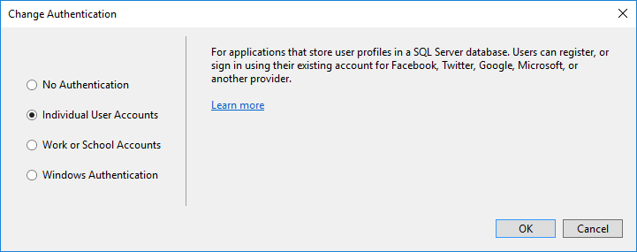

1. Select **Individual User Accounts** (we will connect the signin to a database in a later hands on lab)
2. Click **OK**
3. Click **OK** to create the project
4. Once the project is created, **right click the web project** in the Solution Explorer and select **Publish…**

This will show the new publish interface.

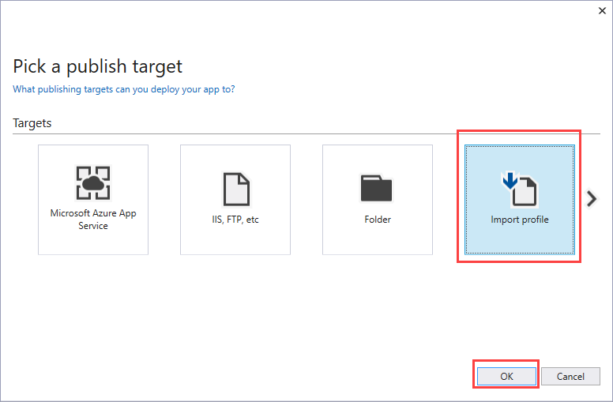

1. Select the **Import Profile** option and click **OK**
2. Go back to the Azure portal and to the Web App (you created in Exercise 1) and to the overview blade
3. Click on the Get publish profile button in the middle top bar

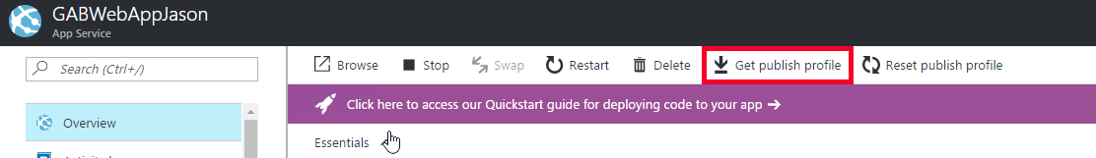

This will download the publish profile for the web app.

Back in Visual Studio, the Import Publish Settings File dialog should be open.

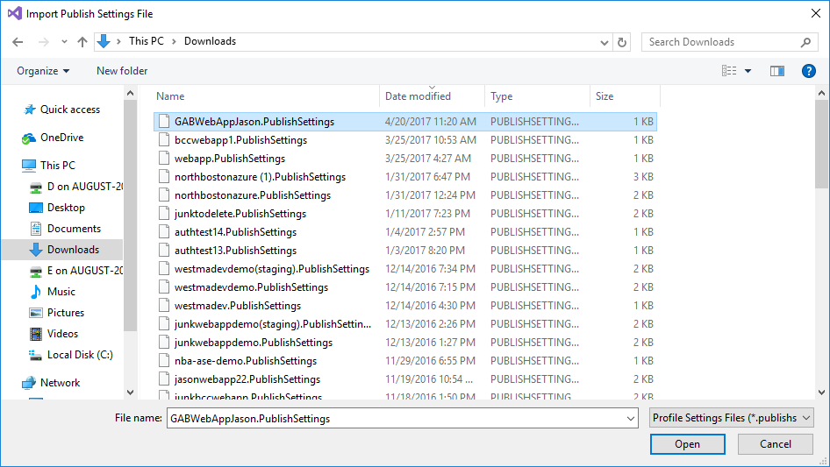

1. Find your publish settings file you just downloaded and click the Open button
2. Click the Publish button to start the deployment

Once the deployment is completed, your default browser should open to the deployed web app.

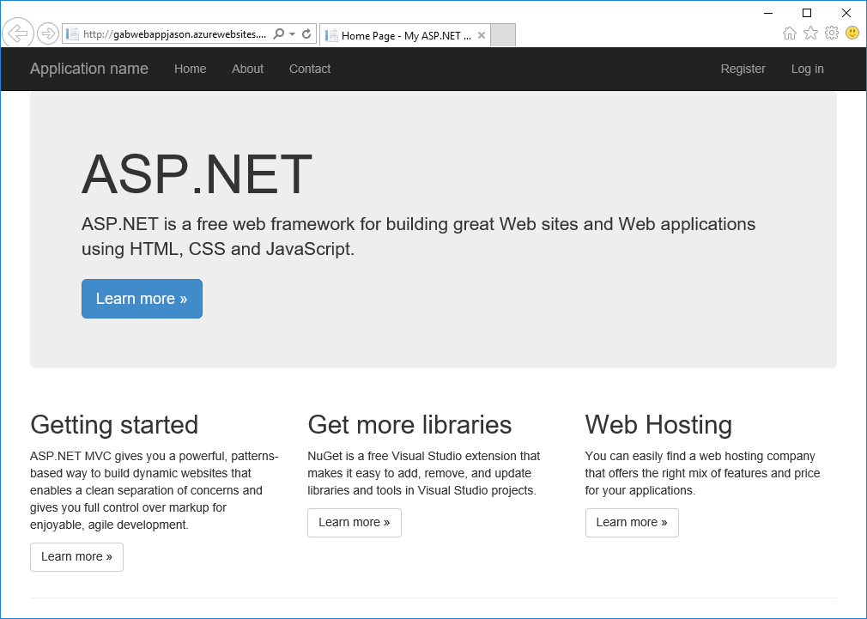

You now have deployed the sample web application code to the web app in Azure.